भारत मौसम विज्ञान विभाग |  | India Meteorological Department
Tuesday 19th May 2026 (29th Vaisakha 1948 Saka)
Summary of observations recorded at 0830 hours IST: The Northern Limit of Monsoon continues to pass through 6°N/70°E, 6°N/75°E, 7°N/80°E, 9°N/85°E, 12°N/90°E, 14°N/93°E, 16°N/96°E and 17.5°N/98°E. Conditions are favourable for further advance of southwest monsoon into some more parts of southeast Arabian Sea, Comorin Area, southwest and southeast Bay of Bengal, remaining parts of Andaman Sea, and some more parts of eastcentral Bay of Bengal during next 3-4 days. The Southwest Monsoon is likely to set in over Kerala on 26th May with a model error of ± 4 days. The Western Disturbance as a cyclonic circulation over north Iran & neighbourhood lay over north Pakistan and adjoining Jammu between 3.1 & 5.8 km above m. s. l. at 0530 hrs IST of today morning. It then persisted and seen between 1.5 & 3.1 km above m. s. l. with a trough aloft in middle tropospheric westerlies with its axis at 5.8 km above m. s. l. ran roughly along Long. 72°E to the north of Lat. 31°N. The upper air cyclonic circulation over northeast Uttar Pradesh & adjoining Bihar lay over East Uttar Pradesh & neighbourhood and extended upto 1.5 km above m. s. l. A trough ran from the cyclonic circulation over northeast Uttar Pradesh & adjoining Bihar to south Assam at 0530 hrs IST of today morning. It ran from the cyclonic circulation over East Uttar Pradesh & neighbourhood to Manipur across north Gangetic West Bengal and Bangladesh at 0.9 km above m. s. l. The trough from the West Madhya Pradesh to Lakshadweep area ran from the East Uttar Pradesh to Lakshadweep area across Madhya Maharashtra, Marathwada, Interior Karnataka & Kerala and extends upto 1.5 km above m. s. l. The upper air cyclonic circulation over south Coastal Andhra Pradesh & neighbourhood between 3.1 & 5.8 km above m. s. l. persisted. The trough from southeast Arabian Sea adjoining south Lakshadweep area to the cyclonic circulation over south Coastal Andhra Pradesh across Kerala, South Interior Karnataka and Rayalaseema between 3.1 & 5.8 km above m. s. l. persisted. An upper air cyclonic circulation lay over central Assam at 1.5 km above m. s. l. The upper air cyclonic circulation over Sub-Himalayan West Bengal & neighbourhood became less marked at 0530 hrs IST of today morning.
Maximum Temperature Departures (as on 18-05-2026): markedly above normal (5.1°C or more) at a few places over Jammu & Kashmir; at isolated places over Himachal Pradesh, West Madhya Pradesh; appreciably above normal (3.1°C to 5.0°C) at a few places over Haryana-Chandigarh-Delhi, Madhya Maharashtra, Marathwada, Vidarbha; at isolated places over Bihar, East Madhya Pradesh, East Rajasthan, East Uttar Pradesh, Gangetic West Bengal, Gujarat Region, Odisha, Punjab, Uttarakhand, West Rajasthan, West Uttar Pradesh; above normal (1.6°C to 3.0°C) at many places over Jharkhand; at a few places over Saurashtra & Kutch; at isolated places over Assam & Meghalaya, Coastal Andhra Pradesh & Yanam, Konkan & Goa, South Interior Karnataka, Tamil Nadu, Puducherry & Karaikal, Telangana and Below normal/ near normal over rest parts of the country. The highest maximum temperature of 47.6°C was reported at BANDA (UTTAR PRADESH).
Hailstorm (from 0830 hours IST of yesterday to 0830 hours IST of today): reported at isolated places over Odisha.
Heat wave to severe heat wave conditions (from 0830 hours IST of yesterday to 0830 hours IST of today): Heat wave to severe heat wave conditions prevailed in isolated pockets over East Uttar Pradesh; heat wave conditions in some pockets of Madhya Pradesh and Vidarbha.; in isolated pockets over Jammu Division, West Uttar Pradesh and Rajasthan.
Warm Night conditions (from 0830 hours IST of yesterday to 0830 hours IST of today): prevailed at isolated places over Vidarbha.
Preliminary Earthquake Report: An earthquake shock of Moderate intensity at its origin with epicenter at Lat. 16.603° North and Long. 96.153°East, 505 km SSW of Namsang; Myanmar about 2369 kms away from Pune, was recorded by the seismographs in the meteorological Office Pune at 07 Hrs. 39 Min. 19 Secs. IST on 18-05-2026 having its magnitude 5.1 on the Richter scale.
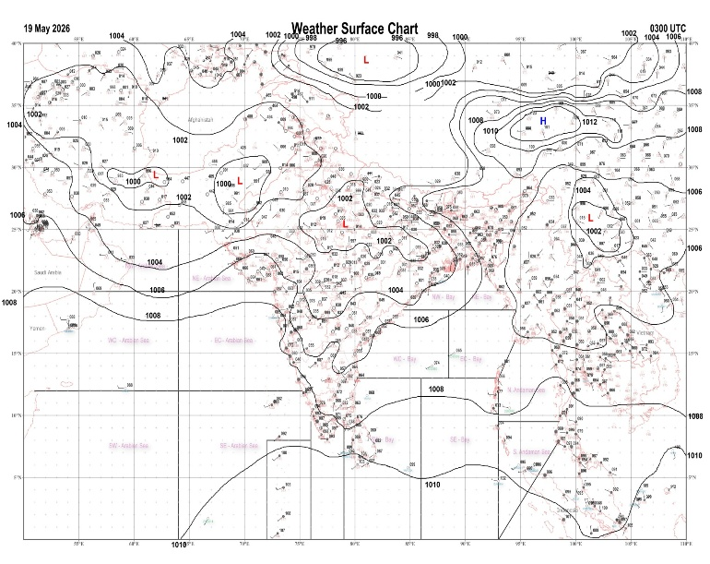 | 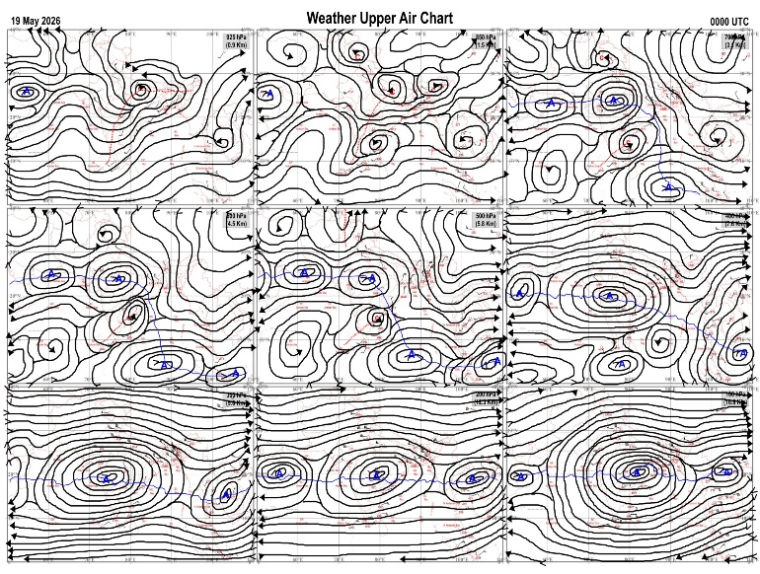
Fig.1. Analysed surface chart based on 03z observation | Fig.2. Analysed upper air chart based on 00z observation
Dr. Sudeep b.l.
Scientist ‘D’
CR & S Office, Pune  Issued at 1245 hrs. IST |  | Weather Forecasting Division  CR&S, Pune

Indian regions | Realised rainfall (chief amount in cm during past 24 hrs):
East | a few places: Arunachal Pradesh, Assam & Meghalaya, Nagaland-Manipur-Mizoram-Tripura and Sub-Himalayan West Bengal & Sikkim  isolated places: Gangetic West Bengal, Odisha+ and Jharkhand  dry weather: Bihar  Similiguda 6.9, Jhallong 6.1, Barpeta 5.9, Chalouni tea estate 4.5, B p ghat 4.0, Bano simdega kvk AWS 3.1, Deomali AWS 2.8, Sabroom & Nh5 gobindpur 2.7 each, Udaipur & Amtala 2.6 each, Silchar 2.4, Berhampore 1.9, Naharlagun AWS 1.8, Agartala AP & Krishnanagar 1.6 each, Tadong & Simdega 1.5 each, Balasore 1.1, Bomdila 0.3, Jamshedpur AP 0.1.
North | isolated places: Jammu-Kashmir and Ladakh◆  dry weather: Uttar Pradesh, Uttarakhand, Haryana, Punjab, Himachal Pradesh and Rajasthan  Bandipora AWS & Kupwara 0.1 each.
Central | dry weather: Madhya Pradesh, Vidarbha and Chhattisgarh
Peninsula | many places: south interior Karnataka and Kerala  a few places: coastal Karnataka  isolated places: Konkan & Goa, Madhya Maharashtra, coastal Andhra Pradesh, Telangana, Rayalaseema, Tamil Nadu+ and north interior Karnataka  dry weather: Gujarat State and Marathwada  Nalumukku 10.2, Oothu 9.2, Hoskote 6.2, Bailhongal 6.0, Nayakanahatty 4.6, Lower sholayar AWS 4.4, Punganur 3.9, Mavelikara 3.8, Kanyakumari 3.7, Gadag PBO & Hubballi 3.6 each, Thiruvananthapuram 2.7, Bengaluru city 2.6, Amadagur 2.5, Brahmavar AWS 1.7, Arogyavaram & Kota 1.6 each, Paderu & Gandhari 1.1 each, Panjim & Karwar 0.8 each, Mapusa 0.6, Vaibhavwadi & Yellareddy 0.5 each, Ajra 0.4, Chandgad 0.3.
Islands | many places: Lakshadweep  a few places: Andaman & Nicobar  Hut bay 3.5, Car Nicobar 2.7, Agathi 2.6, Minicoy 0.6, Port blair 0.4.
Table-2 Forecast / warnings (distribution of rain / thundershowers) for 7 days (valid from time of origin upto 0830 hrs IST of next day)
Sr N. |  | Sub-division Name | Day 1 | Day 2 | Day 3 | Day 4 | Day 5 | Day 6 | Day 7 | Sr. No. | Sub-division Name | Day 1 | Day 2 | Day 3 | Day 4 | Day 5 | Day 6 | Day 7
 |  |  | 19 May | 20 May | 21 May | 22 May | 23 May | 24 May | 25 May |  |  | 19 May | 20 May | 21 May | 22 May | 23 May | 24 May | 25 May
 | 1 | Andaman Nicobar Islands | W +  | W +  | W +  | W +  | W +  | W +  | W +  | 19 | west Madhya Pradesh | D + | D + | D + | D + | D + | D + | D +
 | 2 | Arunachal Pradesh | S | S | S  | F +  | W++ | W ++ | W++ | 20 | east Madhya Pradesh | D + | D + | D + | D + | D + | D+ | D+
 | 3 | Assam-Meghalaya | I  | S  | S +  | F +  | W ++  | W ++ | W ++ | 21 | Gujarat region | D | D | D | D | D | D | D
 | 4 | Nagaland-Manipur-Mizoram-Tripura | S  | S  | S  | F +  | F +  | W + | W+ | 22 | Saurashtra and Kutch | D | D | D | D | D | D | D
 | 5 | Sub Him West Bengal/Sikkim | S  | F  | W +  | W ++  | W ++  | W +  | W +  | 23 | Konkan and Goa | I  | I  | I | I | I | I | I
 | 6 | Gangetic West Bengal | S  | S  | I | I  | I  | I | I | 24 | Madhya Maharashtra | I  | I  | I | I | I | I | I
 | 7 | Odisha | I  + | I  + | I  + | I  + | I  + | I  | S  | 25 | Marathwada | I + | I + | D | D | D | D | D
 | 8 | Jharkhand | I  | I  | I | I  | I  | I | I | 26 | Vidarbha | I + | D + | D + | D + | D + | D+ | D+
 | 9 | Bihar | S++ | S  | I  | I  | S  | I | I | 27 | Chhattisgarh | I + | D + | D + | D + | D + | D | D
 | 10 | east Uttar Pradesh | D + | D + | D + | I + | I + | I + | I + | 28 | Coastal Andhra Pradesh and Yanam | I  + | I  + | I  + | I  + | I  + | D + | D +
 | 11 | west Uttar Pradesh | D + | D + | D + | D + | D + | D+ | D+ | 29 | Telangana | I+ | I  + | D + | D + | D + | D | D
 | 12 | Uttarakhand | I + | I + | I + | I  | I  | I | I | 30 | Rayalaseema | S  | S  | S  | I  | I  | I | I
 | 13 | Haryana,Chandigarh and Delhi | D + | D + | D + | D + | D + | D + | D+ | 31 | Tamil Nadu, Puducherry and Karaikal | S +  | I +  | I+ | I  | I  | S  | S
 | 14 | Punjab | D + | D + | D + | D + | D + | D + | D+ | 32 | Coastal Karnataka | F  | S  | I  | I | I | I | I
 | 15 | Himachal Pradesh | I + | I + | I  | I  | I | I | I | 33 | North interior Karnataka | S  | I  | I  | I  | I  | I | I
 | 16 | Jammu-Kashmir and Ladakh | S + | S+ | F  | S  | S | S | S | 34 | South interior Karnataka | S +  | S  | I  | I  | I  | I | I
 | 17 | west Rajasthan | D + | D + | D + | D + | D + | + | D+ | 35 | Kerala and Mahe | W + | W +  | W+ | F | F | F | F
 | 18 | east Rajasthan | D + | D + | D + | D + | D + | D + | D+ | 36 | Lakshadweep | W+  | W +  | W | F | F | F | F
Legends: D = Dry I =isolated S = Scattered F = Fairly widespread W = Widespread #= heavy to very heavy rain at a few places with extremely heavy rain at isolated places+++= heavy rain at a few places with very heavy rain at isoIated places++= heavy to very heavy rainfall @=isolated exceptionally heavy rainfall+ = heavy rain ●/*= rain or snow ♦ = very light rain ≡=fog = thunderstorm with lightning =Squall / Gusty / gale / strong wind -=cold wave/cold day + = heat wave/warm night/hot and humid weather =Duststorm =ground frost = Hail.

Fig. 4: Districtwise warnings for five days for Maharashtra State
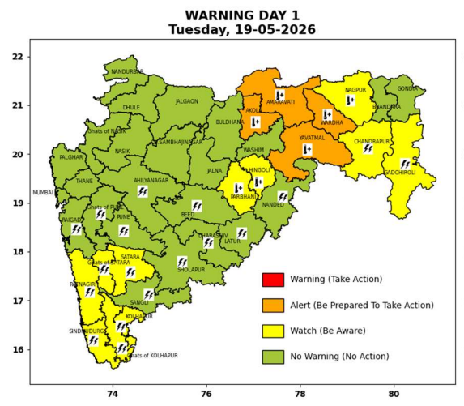 | 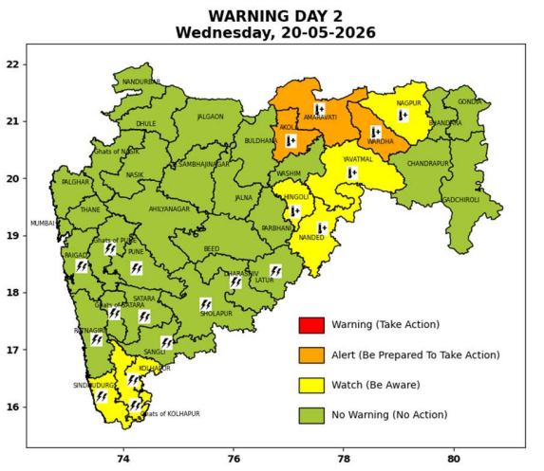 | 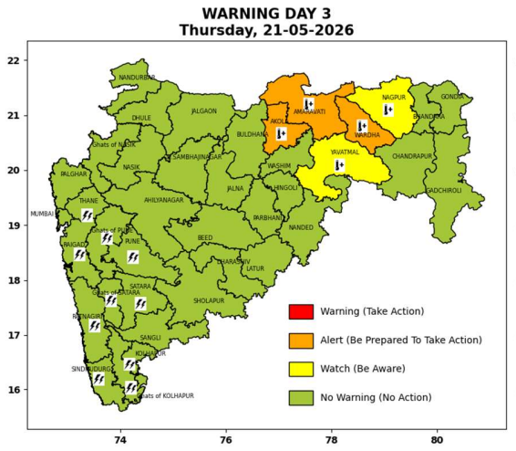 | 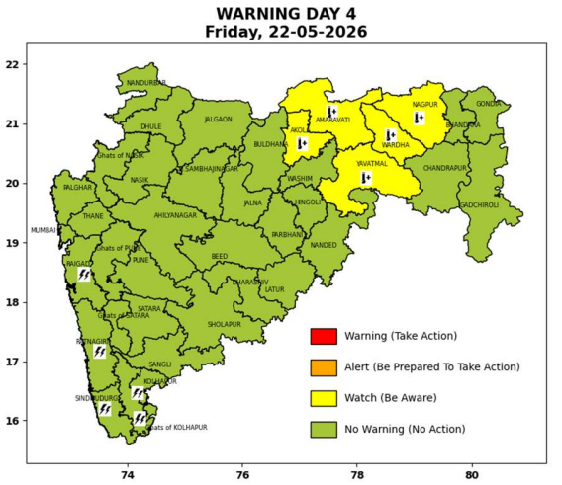 | 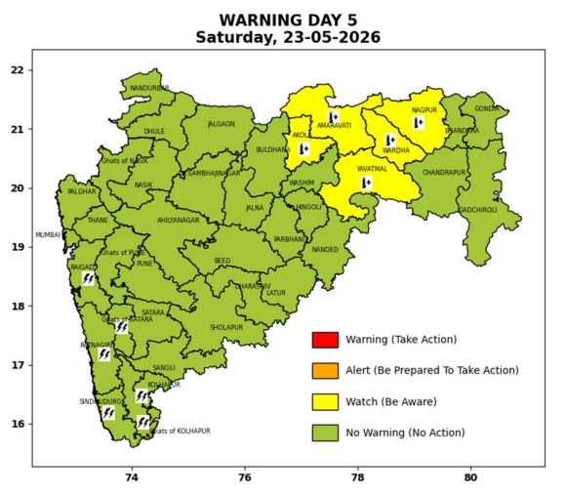

Pune, Lohegaon and Pashan observations at 0830 hrs. IST of Today
 | Temperature (°C) |  |  |  |  | Humidity (%) |  |  |  | Rainfall (mm)
 | Max.  past  24 hrs | Dep.  from  normal | Min.  past  24 hrs. | Dep.  from  normal | Dry  Bulb | At 0830 hrs. IST | Dep.  From  normal | At 1730  hrs. IST of y’day | Dep.  from  normal | Past  24 hrs. | Since  1st March | Dep.  from  normal
PNE | 40.0 | 3.1 | 25.5 | 2.1 | 29.4 | 45 | -15 | 31 | -7 | 0.0 | 92.8 | 62.6
PSN | 40.3 | - | 23.9 | - | 27.4 | 87 | - | 37 | - | 0.0 | - | -
LHG | 41.8 | 4.8 | 25.4 | 4.4 | 29.0 | 49 | -11 | 23 | -13 | 0.0 | 91.4 | 56.5

 |  |  |  |  |  |  | Local (Pune and neighbourhood) forecast
Max./Min. Temperature (°C) |  |  |  |  |  |  |  |  | Weather
Date | Pune | Pashan | Lohegaon | Chinchwad | Lavale | Magarpatta | NDA | Koregoan park
19/05/26 | 37 / 25.5* | 37 / 23.9* | 38 / 25.4* | 37 / 25.7* | 37 / 21.9* | 41 / 26.5* | 37 / 23.5* | 37 / 27.1* | Mainly clear sky becoming partly cloudy sky towards afternoon or evening.
20/05/26 | 38 / 24 | 38 / 24 | 39 / 25 | 37 / 25 | 37 / 23 | 40 / 26 | 37 / 23 | 38 / 27 | Mainly clear sky becoming partly cloudy sky towards afternoon or evening.
21/05/26 | 38 / 24 | 38 / 24 | 39 / 25 | 37 / 25 | 37 / 23 | 40 / 26 | 37 / 23 | 38 / 27 | Mainly clear sky becoming partly cloudy sky towards afternoon or evening.
22/05/26 | 38 / 24 | 38 / 24 | 38 / 25 | 37 / 25 | 36 / 23 | 39 / 26 | 37 / 23 | 38 / 27 | Mainly clear sky becoming partly cloudy sky towards afternoon or evening. Thunderstorm with lightening, very light rain likely.
23/05/26 | 38 / 23 | 38 / 23 | 38 / 24 | 36 / 24 | 36 / 22 | 39 / 25 | 37 / 22 | 37 / 26 | Mainly clear sky becoming partly cloudy sky towards afternoon or evening. Thunderstorm with lightening, very light rain likely.
24/05/26 | 37 / 23 | 37 / 23 | 37 / 24 | 36 / 24 | 36 / 22 | 38 / 25 | 37 / 22 | 37 / 26 | Mainly clear sky becoming partly cloudy sky towards afternoon or evening. Thunderstorm with lightening, very light rain likely.
25/05/26 | 37 / 23 | 37 / 23 | 37 / 24 | 36 / 24 | 36 / 22 | 38 / 25 | 37 / 22 | 37 / 26 | Mainly clear sky becoming partly cloudy sky towards afternoon or evening. Thunderstorm with lightening, very light rain likely.
Rainfall Distribution |  |  |  |  | Rainfall Categories | Rainfall (mm) | Cloud condition |  | Rainfall Intensity | Range
Widespread (W) | 76-100% |  |  |  | Very Light rain | Trace to 2.4 mm | Mainly clear sky | 1-2 oktas | Light Spell | 1 cm/hr
 |  |  |  |  | Light rain | 2.5 to 15.5 mm | Partly cloudy sky | 3-4 oktas | Moderate Spell | 1-2 cm/hr
Fairly Widespread (FW) | 51 – 75% |  |  |  | Moderate rain | 15.6 to 64.4 mm | Generally cloudy sky | 5-7 oktas | Intense Spell | 2-3 cm/hr
Scattered (S) | 26 – 50% |  |  |  | Heavy rain | 64.5 to 115.5 mm | Overcast | 8 oktas | Very Intense Spell | 3-5 cm/hr
Isolated (I) | 1 – 25% |  |  |  | Very heavy rain | 115.6 to 204.4 mm |  |  | Extremely Intense Spell | 5-10 cm/hr
Dry (D) | No Rain |  |  |  | Extremely heavy rain | ≥ 204.5 mm |  |  | Cloudburst | > 10 cm/hr
Probability Terms in %: |  |  |  |  | Heavy snow | 6.5 to 11.5 cms water equivalent of rain
unlikely | < 25 |  |  |  | Very heavy snow | 11.6 to 20.4 cms water equivalent of rain
likely | between 25 50
very likely | between 51 75
most likely | >75
* = realized temperatu
Mumbai (Colaba) |  |  |  | Nagpur (AP)
Date 2026 | T max °C | T min °C | Weather | T max °C | T min °C | Weather
19/05/26 | 33 | 27 | Clear sky. | 45 | 28 | Heat Wave.
20/05/26 | 33 | 28 | Clear sky. | 45 | 28 | Heat Wave.
21/05/26 | 33 | 27 | Clear sky. | 45 | 27 | Heat Wave.
22/05/26 | 33 | 27 | Clear sky. | 45 | 26 | Heat Wave.
23/05/26 | 33 | 28 | Clear sky. | 45 | 26 | Heat Wave.
24/05/26 | 33 | 28 | Clear sky. | 45 | 26 | Heat Wave.
25/05/26 | 33 | 28 | Clear sky. | 45 | 26 | Heat Wave.

